Welcome to Woodchester Playgroup 
Woodchester Playgroup has been established in the village for over 35 years. We are Situated in the grounds of the Ofsted “outstanding” Woodchester Endowed Primary School with which we share close links. A dedicated and wonderful small team of staff encourages the children to flourish and grow.
Our Sessions: Woodchester Playgroup accept children from 2 years to school age. We are open during term time only; our daily opening hours are: Monday to Friday 9 - 3
Fees: Children can attend mornings only (9-12 - £16.50) or all day (9-3 - £33.00). Fees are payable on a half termly basis (about 6 weeks) and each school year consists of 6 half terms. Parents are invoiced by email at the beginning of each half term and the Payment should be settled by the due date. Please note fees are still payable even if your child is absent through illness or holiday.
Applying for a place: If you are interested in a place for your child and would like to arrange a visit Contact us at woodchesterplaygroup@eygloucestershire.co.uk .
Funding: Children become eligible for funding the term after their third birthday, and this provides them with 15 free hours a week of childcare. Children attending more than 15 hours a week will be invoiced for the shortfall unless you are eligible for the 30 hours funding. Also, up to 15 hours for eligible working families with a 2-year-old. Check online for details www.childcarechoices.gov.uk - If you are already signed up, remember to reconfirm your details every 3 months or your code will expire.
Meals and Snacks: The children will be offered a snack mid-morning. Snacks will promote healthy eating such as fruit, breadsticks, carrot sticks, cheese and crackers. We offer a drink of milk at this time, and water will be available throughout the day. Children staying all day will need to bring in a
healthy packed lunch and water bottle.
Uniform: Playgroup sweatshirts and T-shirts are available to purchase from Batemans in Stroud.
Wow vouchers/Learning at home: We encourage you to share your child’s achievements and success at home. Please share completed Wow vouchers to celebrate at playgroup.
Learning Journey: Each child will have their own learning Journey which will be completed by their key person. This will include photos, art, activity sheets, wow vouchers and observations. There will be a charge of £20.00 which will be payable when your child starts at playgroup.
Absence/Illness: Please let us know if your child will be absent from their session.
Fundraising: We are a registered charity and to enable us to keep our fees low, we rely on various fundraising events throughout the year. We depend on your help for this. All parents are welcome to share any ideas at our committee meetings.
Policies: On our website or we hold a copy in setting. There is a No smoking on site policy.
Unofficial one-way system: Approach Church Road from the top by The Royal Oak and follow the road around past the church or park further away and walk in. No stopping or parking on the zigzags.
Drop off/Pick up arrangements: Drop off at 9am – Enter the school car park, through the tall green gate next to the school reception and wait on the back playground. Staff will come out to the playground and ring the bells; the children will filter into the playgroup building. Please be on time as the gate will be closed promptly by school staff. Pick-up - Please green gate, by the school reception. We will bring the children to the gate. Please ensure you leave the playground promptly (unless collecting a school child). For a 12 pick-up, please wait outside the gates in the staff carpark outside the school reception area.
Playgroup Routine
9.00am: Children arrive and are settled down, self registrating with their picture on our ‘Who’s here today?’ board.
9.05am: Children choose their own learning and free play. Child initiated art and craft along with Adult led art, craft and cooking activities. sand/water/sensory play. Mark making.
09.50am: Bells are rung for “Tidy up time” Children encouraged to help with tidying up, putting toys away and caring for their environment.
10.00am: “Talk about time” Children come together as a whole group in the book corner. We talk about the days of the week/month/birthdays, weather, how many children/adults. We use our daily board as a visual aid and children help to stick on pictures/numbers etc. The children share their news, ideas and opinions – encouraging listening skills and taking turns.
10.10am: Toilet/Wash hands before snack time in our key groups.
10.30am: Children choose and look at books.
10.45am: Outside Play: mud kitchen, ride on vehicles, hoops, tyres, ladders, bats/balls, sand/water, large construction, tents and tunnels, chalks, musical instruments, loose parts play.
11.45am: Circle time, story, rhymes and songs.
12.00pm: End of session for morning children and Lunchtime.
12.45pm: Children choose their own learning/free play, small group activities. Inside and outside play.
2.30pm: Afternoon drink. Storytime, games and rhymes.
3.00pm: Home time.
Staff
Sophie Cooper – Playgroup Manager/ Safeguarding Lead/ SENco
Sarah Knight – Deputy Manager/ Deputy Safeguarding Lead
Sabine Rickett – Play Assistant

Key Person
Each child will be allocated a key person. Their role is to help ensure that every child’s care is tailored to meet their individual need and to help the child become familiar with the setting. Your child’s key person will use observations, assessments and planning based on the EYFS and your child’s interests to help them learn, develop and grow.
Contact Details

Woodchester Playgroup,  Church Road, | Telephone: 01453 873004
North Woodchester,  Stroud,  GLOS  GL55PD | Email: woodchesterplaygroup@eygloucestershire.co.uk
Ofsted Registration Number: 101715
Registered Charity Number: 292714

Registration Form

Child‛s first name: M / F: | Surname: | Date of birth:

Parent/Guardian details
Title: | First name: |  | Surname: |  | Title: | First name: |  | Surname:
Home address:  Does the child normally live at this address? Yes No |  |  |  |  | Home address (if different):  Does the child normally live at this address? Yes No
Home number: |  | Mobile number: |  | Work number: | Home number: |  | Mobile number: |  | Work number:
Email address: N.I number: |  |  |  |  | Email address: N.I number:
Does this person have parental responsibility? Yes No |  |  |  |  | Does this person have parental responsibility?Yes No
Does anyone else have parental responsibility for this child? Yes |  |  |  |  | / No (If yes)
Additional Emergency Contact Details (please provide details of two people we can contact and would be able to collect your child if we are unable to get hold of you)
Name: | Telephone number: | Mobile number:
Address: |  | Relationship to the child:
Name: | Telephone number: | Mobile number:
Address: |  | Relationship to the child:
People Authorised by you to collect your child: |  | Password:

Child‛s Doctor
Name of Doctor:
Surgery Name and Address: | Telephone:
Additional Information (optional)

Childs first language:  Other languages spoken by child: | Family religion: | Ethnic origin:
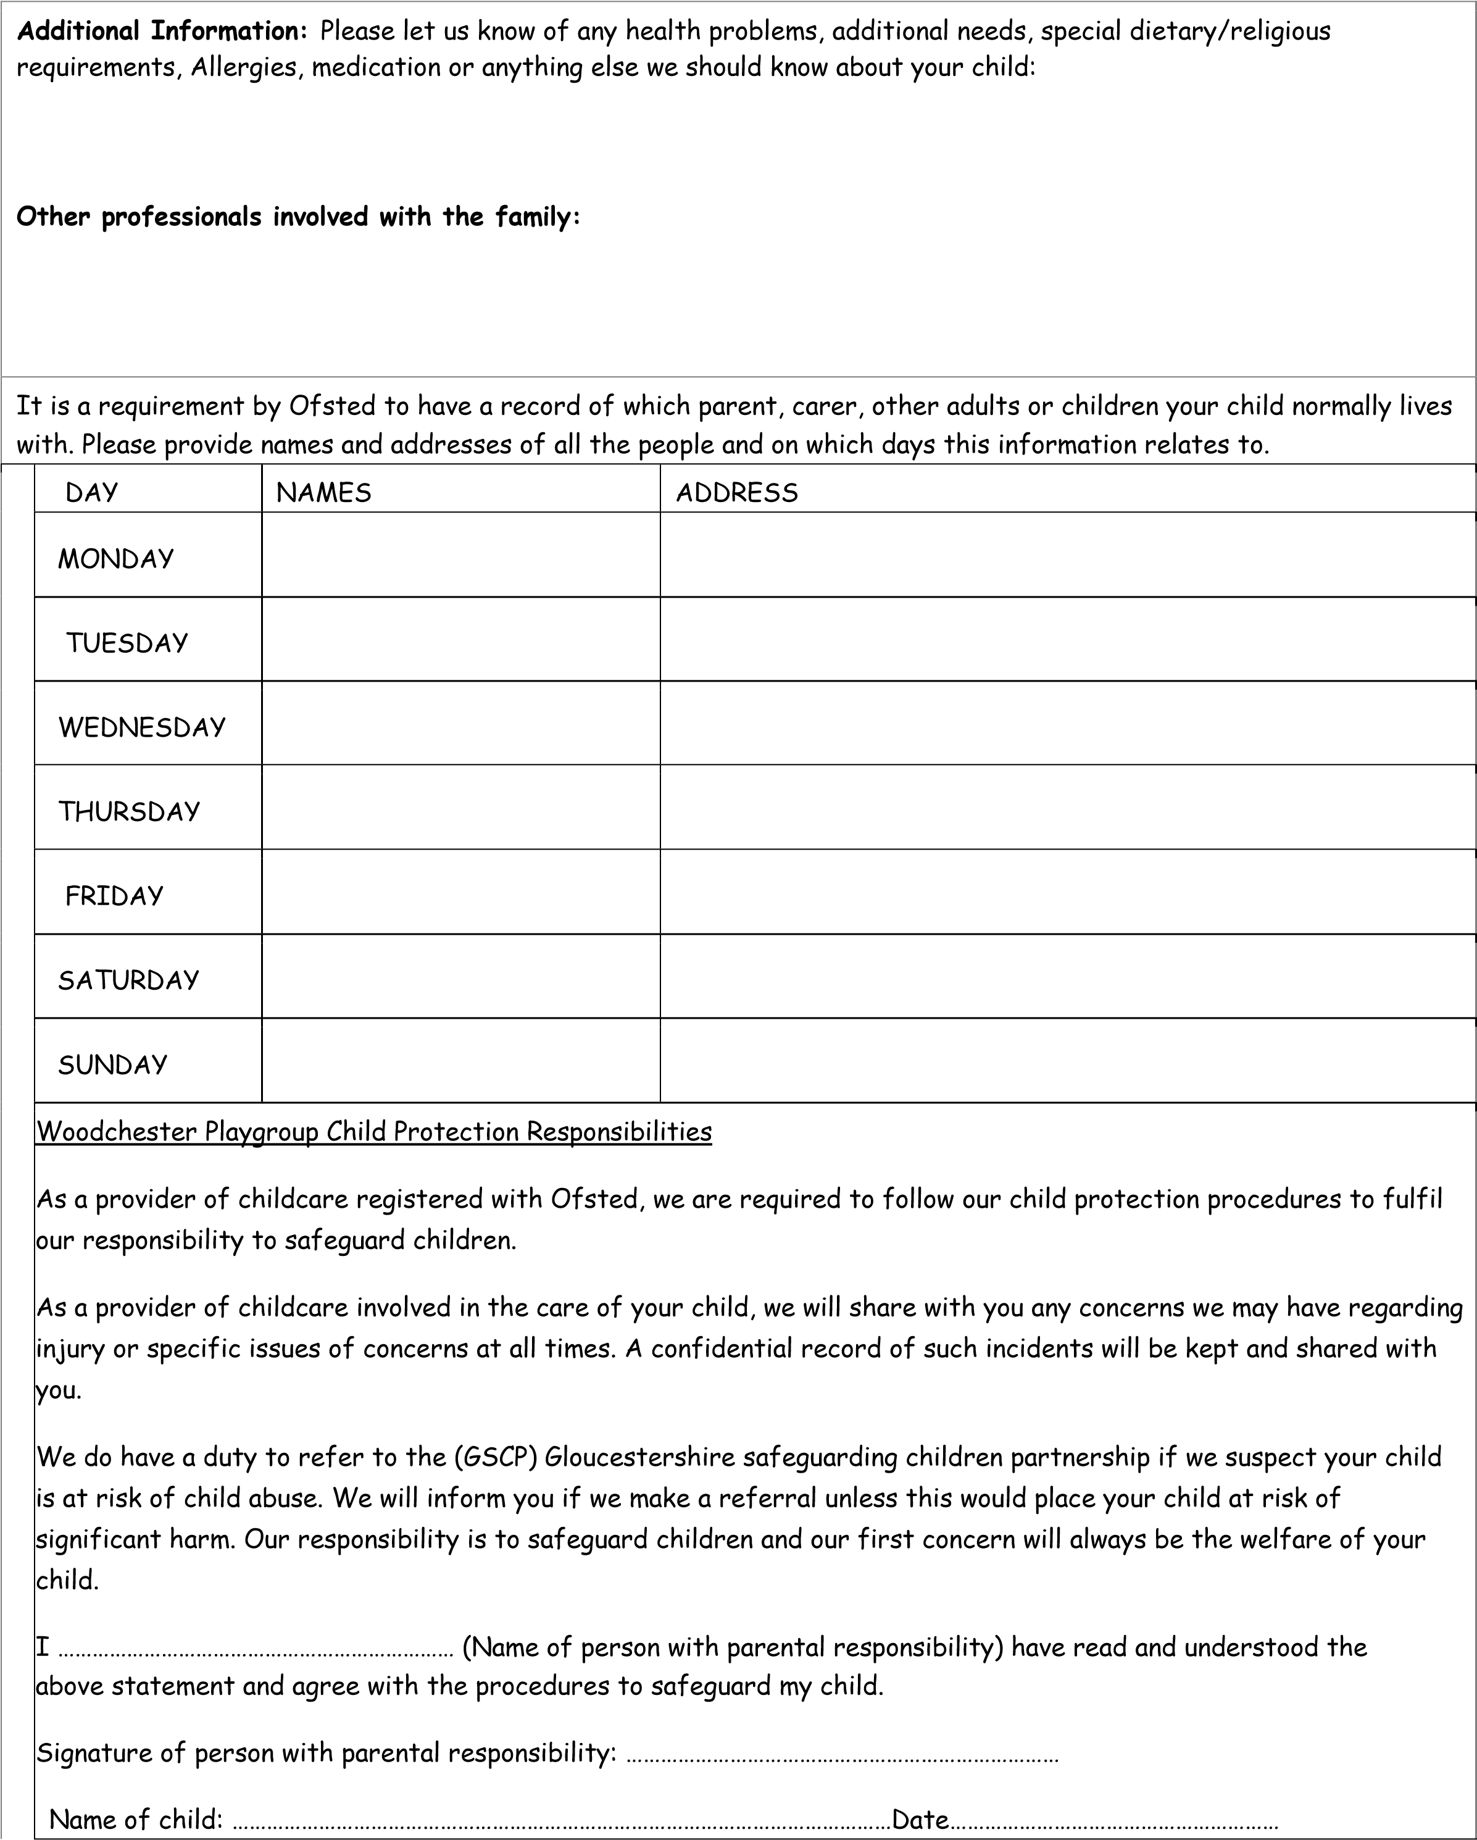

Woodchester Playgroup Booking Form
Name of Child: …………………………………………………………………
Date of Birth:…………………………………………………………………
Start Date
Woodchester playgroup charges an hourly rate of £5.50
I would like to book the following sessions:
 | 9 – 12pm  £16.50 | 9 – 3pm  £32.00
Monday
Tuesday
Wednesday
Thursday
Friday
Notes
Please confirm if eligible for:
Early Years Free Entitlement. YES NO
Top up payment. YES NO
I agree to the above sessional times and costs. If I do not receive funding or need to pay a top up, I will pay the invoice by the due date.
Payment Terms and conditions.
- You will be invoiced by email half termly for the sessions you have booked for your child. A minimum of two sessions is required.
- Fees must be paid by the due date.
- All absences previously booked must be paid for.
- Please notify the playgroup if your child will be absent from their session.
- If invoices are not paid on time your space will be cancelled and methods sought to redeem outstanding payments.
- The penalty charge for continued late collection is £5.00 for every five minutes.
- If a child has not been collected at the end of their session, we will follow our uncollected children procedure.
- Fees may increase periodically in order to cover running costs. You will be notified of any increases.
- A registration fee of £25 will be payable to secure your child’s place, this must be paid by bank transfer.
- A charge of £20.00 for your child’s learning journey will be payable when your child starts playgroup.
I have read and agree to the Terms and Conditions of Woodchester Playgroup.
Signed: ……………......................................................... Date: ………………………………….
Privacy Notice/Data Consent – Please read our Privacy notice policy 10.1 on our website
Could you please sign the statements below to ensure you are happy with the collection, storing and processing of personal data and information. Some of the Data will be stored in a manual file in a locked filing cabinet at playgroup and some will be stored on a password protected laptop in a locked filing cabinet at playgroup.
Name of Child: ……………………………………………………………………………
I am happy for Woodchester Playgroup to request and store required information relating to my child’s name, age, additional needs, family details including parent’s details and other family/friend’s details including address, telephone numbers, doctors etc.
SIGN: DATE:
I am happy for my child’s data to be disclosed to authorised recipients relating to childcare vouchers,
Gloucestershire County Council and the administration necessary for Woodchester Playgroup and
Woodchester playgroup financial administrator to perform its duties and obligations eg names on attendance registers, email addresses for invoices, information for funding portal.
SIGN: DATE:
I am happy for my child’s data, if necessary, to be disclosed to authorised parties in relation to my child’s health, safety and welfare eg school teachers and outside professionals. You will be notified unless it puts your child at risk of significant harm.
SIGN: DATE:
I am happy to ask for right of access to my child’s personal data.
SIGN: DATE:
I will ensure that the personal data Woodchester Playgroup hold remains accurate and up to date and will let the Data Protection Lead know of any changes.
SIGN: DATE:
I understand that my child’s personal data will be kept for 3 years after leaving Woodchester Playgroup and disposed of securely when it is no longer required by shredding. (In certain
circumstances up to 21 years)
SIGN: DATE:
I understand that I have the right to restrict processing of my child’s personal data and will let the Data Protection Lead know if I have any concerns.
SIGN: DATE:
I understand Woodchester Playgroup have an appropriate data protection policy.
SIGN: DATE:
Parent/Playgroup contract - To be signed by person with parental responsibility
CHILDS NAME
- I/We understand that parents will be invoiced via email by the playgroup’s financial Administrator. No refunds will be given for absence whether for holidays or sickness unless the latter is long term. Fees will only be refunded for unforeseen circumstances (eg snow/heating) if the closure is for 2 or more consecutive playgroup days. One terms notice (based on 6 terms per annum) is required should I/We no longer require our child’s playgroup place. I give permission for my email and details to be passed to the financial administrator for administrative duties. Yes No
- Photographs are sometimes taken of the children engaged in their usual playgroup activities or if we have special visitors for our playgroup blog and/or for publishing in the local paper/Woodchester word.
I/We give permission for our child’s photograph to be used within the playgroup
I/We give permission for our child’s photo to appear on the playgroup website (unnamed)
I/We give permission for our child’s photo to appear in local publications
Yes No
- I/We give permission for staff to undertake observations of my child as part of the ongoing assessment of my child. These observations will be in the form of photographs and written observations. Any additional observations will be stored in your child’s file. Yes No
- I/We give permission for my child’s photo to be included in other children’s learning journey eg when children are playing together with their friends and accept that other children may be included in my child’s learning journey. Yes No
- I/We give permission for information to be shared with other relevant professionals eg: early years help, speech and language therapy, physiotherapist, health visitor, teacher, Doctor etc
Yes No
- I/we give permission for my child to use/play on the school fort and balancing equipment, playground, tyres, woodland area and use own scooters with helmets. (supervised by staff) Yes No
- I/We understand the staff are only covered by the playgroups insurance to look after our child during playgroup hours (9am-3pm). On arrival prior to the start of the session, I/We are responsible for our child. Once our child has been passed to the collecting adult at the end of the session the staff are no longer responsible for supervising a child. Yes No
- During warm/hot weather, please make sure sun protection cream is applied before your child attends playgroup and that your child brings a sun hat. Yes No
- I/We give permission for my child to go on local walks with staff and volunteers from Woodchester Playgroup. This will always be in small groups with high adult to child ratios. High vis tabards will be worn.
Yes No
- I/We give permission for my child to receive BASIC FIRST AID and/or ANAESTHETIC TREATMENT in hospital in case of a medical emergency during my absence. Yes No
- I/We agree that if any circumstances change, we will immediately notify the staff. Yes No
Parent/Carer Name: Signed: Date:

Consent to Share Information 
This consent form is to be used in conjunction with the information sharing leaflet which outlines your full rights around how we use your information. If the young person is 13+ and has a full understanding then consider completing the consent form with them.
Child/Young Person’s name: |  | DOB:
Parent/Carer’s name:
Parent/Carer’s name:
- I have been informed about the need to share information about me/my child so those working with me/my family can work together.
- I have been given the opportunity to discuss what sharing and not sharing information will mean to me and my family.
- I have received a copy of the sharing information leaflet.
- I understand that my information will be held securely in accordance with the Data Protection Act.
- I understand there may be circumstances where information will be shared without consent and I understand when these are.
[tick one]
 I agree that my/my child’s personal information may be shared between those involved with me/my child
 I do not agree that my/my child’s personal information may be shared between those involved with me/my child.
I agree that my/my child’s personal information may be shared between those involved with me/my child with the exception of: _______________________________
If the young person is aged 13+ and you deem them able to understand the process of consent then you should also ask for their consent.
Signature of Young Person: |  | Date:
Signature of Parent/Carer: |  | Date:
Signature of Parent/Carer: |  | Date:
I have fully explained to the Young Person/Parent/Carer about information sharing and the involvement of other (external) services.
Name of Worker
Signature of Worker: |  | Date:
Agency/Service:

